|  |
| --- |
| Domain: **Entertainment** |

|  |
| --- |
| Module 1: Login/Registration |

|  |  |  |  |  |  |  |
| --- | --- | --- | --- | --- | --- | --- |
| **Sr.no** |  | **Netflix** | **Amazon** **Prime** | **Sony** **Liv** | **Voot** | **Zee5** |
| **1** | **Functionality** | -Login contain Phone /  email and  Password  -Forgot password if don’t  remember it  -Create your account if you  don’t have it  -Give information about email address and register your account. | -Login contain Phone /  email and  Password  -Forgot password if don’t  remember it  -Create your account if you  don’t have it  -Give information about First and Last name, email address and Password registering your account. | -For Login & Sign up contain Phone / email by OTP Verification or Login through google/Facebook accounts. | -Login contain  Email, Facebook or Google.  -Create your account if you  don’t have it by Phone using OTP. | -Login contain Phone /  Email OTP Verification.  -Create your account if you  don’t have it using email/Phone OTP Verification  -Give information about email address, age, Gender and Register your account by OTP Verification. |
| **2** | **Control** | **1.Login**  -Email / phone number (Text input)  -Password (hidden text)  -Log in(button)  -Forgot password (link label)  **2.Reset Link**  -Email / Phone (Text input)  - Reset password(button) **3. New User**  -Name (text input)  -Phone number/email address (text input)  -Date of birth(calendar)  -Sign up (button) | **1.Login**  -Email / phone number (Text input)  -Password (hidden text)  -Log in(button)  -Forgot password (link label)  **2.Reset Link**  -Email / Phone (Text input)  - Reset password(button) **3. New User**  -First + Last Name (text input)  -Email address (text input)  -Password (Hidden Text)  -Sign up (button) | **1.Login**  -Email / phone number (Text input)  -Continue  (button)  -Or sign in with Google/Facebook account (Buttons).  **2. New User**  -Phone number (Text input)  -Continue (button) | **1.Login**  -Email (Text input)/Facebook/Google /Apple (buttons).  -Password (hidden text)  -Forgot password (link label)  -Continue (button)  **2.Reset Link**  -Email / Phone (Text input)  -Reset password(button) **3. New User**  -Phone number (text input)  -Continue (button) | **1.Login**  -Email / phone number (Text input) or Google/Facebook/Twitter/Apple (buttons)  -Log in(button)  **2.New User**  -Phone number/email address (text input)  -Age (Text)  -Gender (Select button)  -Create account  (button) |
| **3** | **Validation** | 1. If the user enters their invalid detail System prompts the Error message  2. During the Signup both passwords are mismatch so prompt the Error message  3. During the Signup if user enter Simple Password so display the error message "Password must be 5 characters long, current password is too short at 4" | 1. If the user enters their invalid detail System prompts the Error message  2. During the Signup both passwords are mismatch so prompt the Error message  3. During the Signup if user enter Simple Password so display the error message "Password must be 5 characters long, current password is too short at 4" | 1. If the user enters their invalid detail System prompts the Error message  2. During the Signup if OTP is mismatch so prompt the Error message  3. During the Signup if user enter invalid OTP so display the error message "Invalid OTP**"**  4. Error while login or sign up through Google/Facebook Account | 1. If the user enters their invalid detail System prompts the Error message  2. During the Signup if OTP is mismatch so prompt the Error message  3. During the Signup if user enter invalid OTP so display the error message "Invalid OTP**"**  4. Error while login or sign up through Google/Facebook Account | 1. If the user enters their invalid detail System prompts the Error message  2. During the Signup if OTP are mismatch so prompt the Error message.  3. During the Signup if user enter invalid OTP so display the error message "Invalid OTP**"**  4. Age if return in characters (abc…) invalid text message. |
| **4** | **Screenshots** | **Sign up**    **Sign in** | **Sign up**    **Sign up** | **Sign in (Create Account)**    **Sign in with Email/Google/Facebook** | **Sign up with Mobile/Sign in with email or Google or Facebook or Apple Account** | **Sign up**    **Sign in** |

|  |
| --- |
| Module 2: Dashboard |

|  |  |  |  |  |  |  |
| --- | --- | --- | --- | --- | --- | --- |
| **Sr.no** |  | **Netflix** | **Amazon Prime** | **Sony Liv** | **Voot** | **Zee5** |
| **1** | **Functionality** | -User is able to watch movies, web series or TV Shows a/c to recommendations, imbd ratings, Trending, Mostly Watched etc.… filters  -Search for searching Movies/Web Series/TV Shows  - User can view movies/web series a/c to genres.  -My list including movies you have watched or will be watched  -Recently Added option for watch latest web series/movies/TV Shows  -Notification  -User profile icon containing settings, my plan, my Wishlist etc.… is available | -User is able to watch movies or web series a/c to amazon originals & Exclusives, recommendations etc.…  -Search for searching Movies/Web Series/TV Shows  - User can view movies/web series a/c to genres and also sports.  -Gift cards and top ups  -My stuff including movies you have watched or will be watched  -Kids for kids’ content  -Free to me  -User profile icon containing log out  -settings containing my plan, my Wishlist etc.… is available | -Categories like  TV, Shows, QOTY, New, WWE, Sports, Movies, Originals & #WatchFree for easy access of content to user  -Search for searching Movies/Web Series/TV Shows/Sports etc.…  -Subscribe option for watching premium content.  -Left to Right Slide bar showing Trending movies/web series/TV Shows  -User profile icon containing settings, contact us, Subscribe, Activate TV, log out etc.… is available | -Categories like My Voot, Premium, Sports, Shows, Movies, Kids, Channels for easy access of content to user.  -Search for searching Movies/Web Series/TV Shows/Sports etc.…  -Left to Right Slide bar showing Trending movies/web series/TV Shows  -User profile icon containing settings,  Help & Legal, Manage Profiles, log out is available | -Categories like TV Shows, Movies, Premium, Web Series, Sports, Live tv, Music, Channels etc.… for easy access of content to user.  -Change Language  - Search for searching Movies/Web Series/TV Shows/Sports etc.…  -Left to Right Slide bar showing Trending movies/web series/TV Shows  -User profile icon containing My Watchlist,  My Subscriptions, My Rentals, My Transactions & log out is available |
| **2** | **Control** | -Netflix(icon)  -Photo (Image)  -Search (text)  -User Profile (icon)  -Categories for Watching(button) | -Amazon Prime(icon)  -Photo (Image)  -Search (text)  -User Profile (icon)  -Categories for Watching(button)  -Gift Cards & Top up (button + text) | -Sony Liv(icon)  -Photo (Image)  -Search (text)  -User Profile (icon)  -Categories for Watching(button)  -Subscribe(button) | -Voot(icon)  -Photo (Image)  -Search (text)  -User Profile (icon)  -Categories for Watching(button) | -Zee5(icon)  -Photo (Image)  -Search (text)  -User Profile (icon)  -Categories for Watching(button)  -Change Language(icon) |
| **3** | **Validation** | -If user enters invalid name of Movies/Web Series/TV Shows then shows “No result found” | -If user enters invalid name of Movies/Web Series/TV Shows then shows “No result found” | -If user enters invalid name of Movies/Web Series/TV Shows then shows “No result found” | -If user enters invalid name of Movies/Web Series/TV Shows then shows “No result found” | -If user enters invalid name of Movies/Web Series/TV Shows then shows “No result found” |
| **4** | **Screenshot** | **Homepage** | **Homepage** | **Homepage** | **Homepage** | **Homepage** |

|  |
| --- |
| Module 3: Subscription/Payment |

|  |  |  |  |  |  |  |
| --- | --- | --- | --- | --- | --- | --- |
| **Sr.no** |  | **Netflix** | **Amazon Prime** | **Sony Liv** | **Voot** | **Zee5** |
| **1** | **Functionality** | **1. Plans**  -Choose plan like Premium, Standard, Basic and Mobile a/c to which content will be provided  **2. Payment**  -Payment options like through debit/credit card, Net Banking or through Visa/Master Cards are Provided | **1. Plans**  -Choose Plan like monthly/yearly or you can also try for 30-day free trial  **2. Payment**  -Payment options like credit/debit cards or other  upi apps are Provided | **1. Plans**  -Choose plans like monthly/yearly/semi-annual or mobile only  -Select a promocode for discount  **2. Payment**  -Payment options like Credit/Debit/ATM Cards, UPI, Net banking or Wallet are Provided | **1. Plans**  -Choose plan of ₹999 for accessing all premium content  -Apply Promocode for Discount.  **2. Payment**  -Payment options like upi or credit/debit cards are Provided | **1. Plans**  -Choose plans like mobile/premium -hd or premium - 4k  -Apply Code for Discount.  **2. Payment**  -Payment options like UPI, credit/debit cards, wallets or net banking are Provided |
| **2** | **Controls** | **1. Plans**  -choose plan (select button)  -next(button)  **2. Payment**  -first name (text: characters only)  -last name (text: characters only)  -card number (text: digits only)  -expiration date (text)  -CVV (text: digits only)  -billing zip code (text: digits only)  -change plan (button)  -price(image)  -start membership (button)  -OTP verification (text: digits only)  -back(button) | **1. Plans**  -choose plan (select button)  -Proceed (button)  **2. Payment**  -choose payment options (select button)  -name on card (text: characters only)  -card number (text: digits only)  -expiration date (select dropdown button)  -price(image)  -continue (button)  -OTP verification (text: digits only)  -back(button) | **1. Plans**  -choose plan (select button)  -select promo code (button)  -pay (button)  -back(button)  **2. Payment**  -choose payment options (select button)  -upi id (text: digits only)  -card number (text: digits only)  -expiration date (text)  -cvv (text: digits only)  -billing zip code (text: digits only)  -price(image)  -OTP verification (text: digits only)  -back(button) | **1. Plans**  -choose plan ₹999 (select button)  -apply promo code (button)  -continue & pay (button)  -For you (button)  -Sports (button)  -Free (button)  -Premium (button)  -More (button)  **2. Payment**  -choose payment options (select button)  -upi id (text: digits only)  -card number (text: digits only)  -expiration date (text: digits only)  -CVV (text: digits only)  -billing zip code (text: digits only)  -price(image)  -proceed to pay (button)  -OTP verification (text: digits only)  -back(button) | **1. Plans**  -choose plan (select button)  -Apply code (button then alpha num text)  -select payment (select button)  -price(image)  -buy premium(button)  **2. Payment**  -choose payment options (select button)  -upi id (text: digits only)  -Card Number (Text: Digits only)  -Expiration Date (Text)  -CVV (Text: Digits only)  -Billing Zip Code (Text: Digits only)  -OTP verification (text: digits only)  -back(button) |
| **3** | **Validation** | -If user enters invalid name, it will show error (like using digits)  -No text will be allowed in card number, cvv, billing zip code & otp verification | -If user enters invalid name, it will show error (like using digits)  -No text will be allowed in card number, cvv, billing zip code & otp verification | -If user enters invalid name, it will show error (like using digits)  -No text will be allowed in card number, cvv, billing zip code & otp verification | -If user enters invalid name, it will show error (like using digits)  -No text will be allowed in card number, cvv, billing zip code & otp verification | -If user enters invalid name, it will show error (like using digits)  -No text will be allowed in card number, cvv, billing zip code & otp verification |
| **4** | **Screenshot** | **Subscription/Plan**  **Payment** | **Subscription/Plan**    **Payment** | **Subscription/Plan**    **Payment** | **Subscription/Plan**    **Payment** | **Subscription/Plan**    **Payment** |

|  |
| --- |
| Module 4: Profile Page |

|  |  |  |  |  |  |  |
| --- | --- | --- | --- | --- | --- | --- |
| **Sr.no** |  | **Netflix** | **Amazon Prime** | **Sony Liv** | **Voot** | **Zee5** |
| **1** | **Functionality** | -user can able to upload their cover photo as well as profile photo  -they can edit their profile on their own choice  -they can change their privacy, account settings etc… | -user can able to upload their cover photo as well as profile photo  -they can edit their profile on their own choice  -they can change their privacy, account settings etc… | -user can able to upload their cover photo as well as profile photo  -they can edit their profile on their own choice  -they can change their privacy, account settings etc… | -user can able to upload their cover photo as well as profile photo  -they can edit their profile on their own choice  -they can change their privacy, account settings etc… | -user can able to upload their cover photo as well as profile photo  -they can edit their profile on their own choice  -they can change their privacy, account settings etc… |
| **2** | **Controls** | -Cover Photo (Image)  -Profile Photo (Image)  -Settings (Icon)  -People (Icon)  -Edit Profile (Icon)  -Username (Text)  -About (Text) | -Cover Photo (Image)  -Profile Photo (Image)  -Settings (Icon)  -People (Icon)  -Edit Profile (Icon)  -Username (Text)  -About (Text) | -Cover Photo (Image)  -Profile Photo (Image)  -Settings (Icon)  -People (Icon)  -Edit Profile (Icon)  -Username (Text)  -About (Text) | -Cover Photo (Image)  -Profile Photo (Image)  -Settings (Icon)  -People (Icon)  -Edit Profile (Icon)  -Username (Text)  -About (Text) | -Cover Photo (Image)  -Profile Photo (Image)  -Settings (Icon)  -People (Icon)  -Edit Profile (Icon)  -Username (Text)  -About (Text) |
| **3** | **Validation** | -invalid username if not contains alpha num characters of particular length  -about max length warning | -invalid username if not contains alpha num characters of particular length  -about max length warning | -invalid username if not contains alpha num characters of particular length  -about max length warning | -invalid username if not contains alpha num characters of particular length  -about max length warning | -invalid username if not contains alpha num characters of particular length  -about max length warning |
| **4** | **Screenshot** | **Profile Page** | **Profile Page** | **Profile Page** | **Profile Page** | **Profile Page** |

|  |
| --- |
| Module 5: Help/Customer Support |

|  |  |  |  |  |  |  |
| --- | --- | --- | --- | --- | --- | --- |
| **Sr.no** |  | **Netflix** | **Amazon Prime** | **Sony Liv** | **Voot** | **Zee5** |
| **1** | **Functionality** | -Search for the help that is needed in the search bar  -Showing top searches for resolving issue in quickest way | -Search for the help that is needed in the search bar  -Showing top searches for resolving issue in quickest way  -settings like account details, register a device, parental controls, watch history and prime video profiles is Provided | -Showing help, a/c to subscription issue, account management, trouble watching content (streaming issues), liv games etc.…  -Frequently asked questions for resolving the issue in a quickest way.  -WhatsApp Chat Bot for asking for help | -Search for the errors/quest in the search bar  -Showing top searches for resolving issue in quickest way | -Search for the help that is needed in the search bar  -Showing top searches for resolving issue in quickest way  -Zee5 customized bot for asking for help. |
| **2** | **Controls** | -Netflix (icon)  -search (text)  -sign in(button)  -join Netflix(button) | -Prime Video (icon)  -search (text)  -menu (select dropdown button) | -Sony Liv (icon)  -select help from the options (select button)  -FAQs (button)  -WhatsApp bot (button) | -jio cinema (icon)  -search (text)  -back to help center(button) | -Zee5 (icon)  -search (text)  -Zee5 (button) |
| **3** | **Validation** | -no help found in records | -no help found in records | -no help found in records | -no help found in records  -WhatsApp bot error | -no help found in records  -Zee5 bot error |
| **4** | **Screenshot** |  |  |  |  |  |

* **My Innovative Idea is Chatbot Integration for legal help & 24/7 Customer Support.**

**Login/Registration Page**

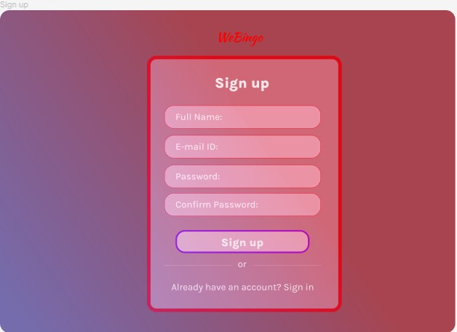

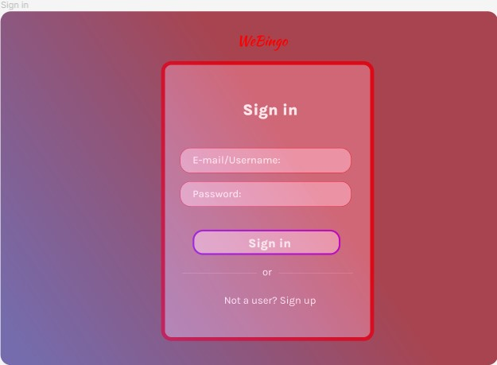

**Dashboard Page**

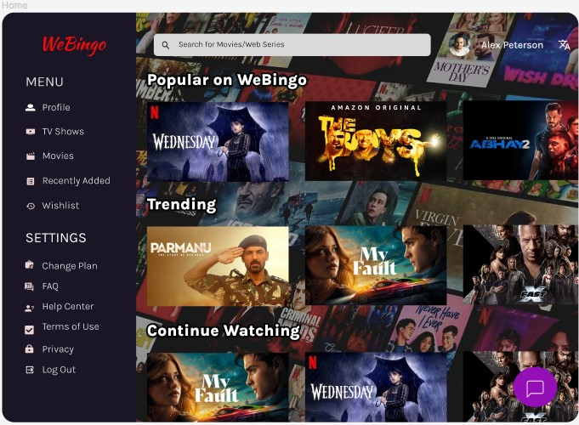

**Help/Customer Support Page**

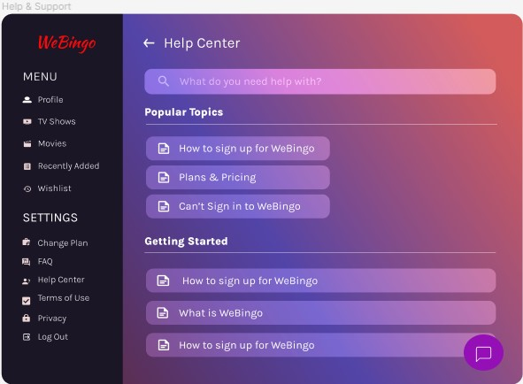

**Payment & Subscription Page**

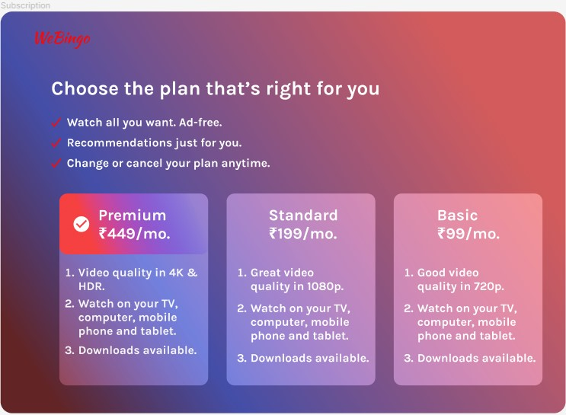

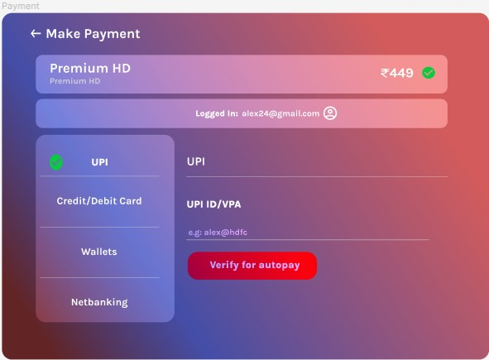

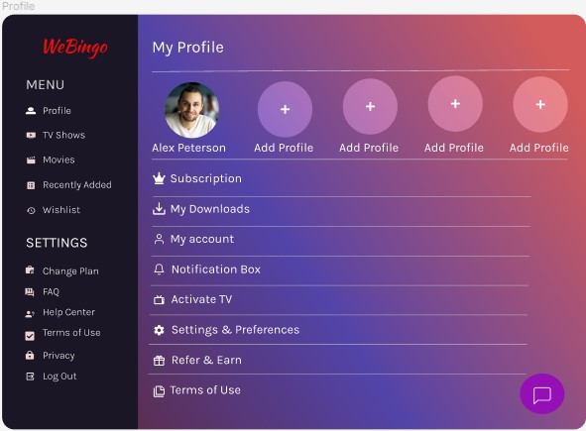**Profile Page**

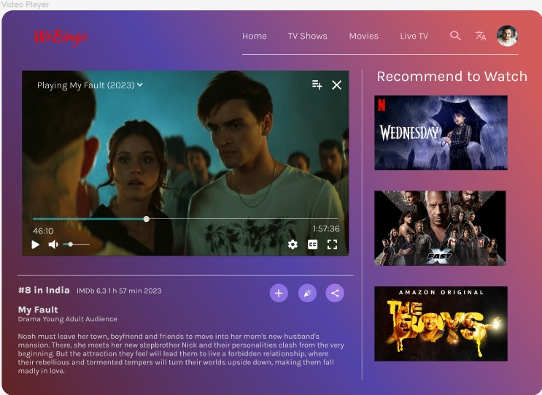**Video Player**

**Wishlist Page**

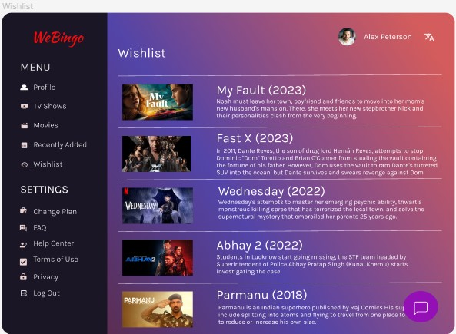

**END**

**Link to My Figma File**

https://www.figma.com/file/zg2jK6VwjpCxkuubzLv9dZ/WeBingo-Web-App?type=design&node-id=0%3A1&mode=design&t=UQstCqLjxX2Gag3Z-1